**Task 1**

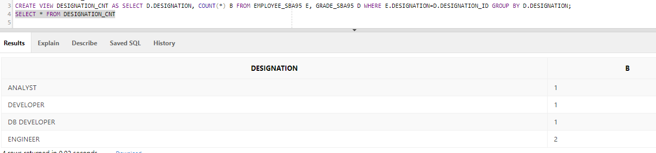

**Task 2**

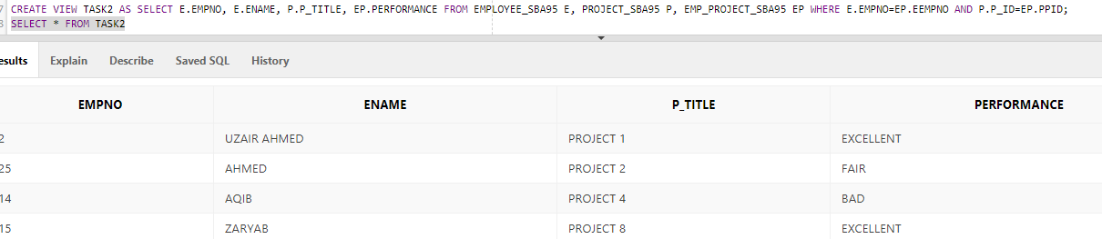

**Task 3**

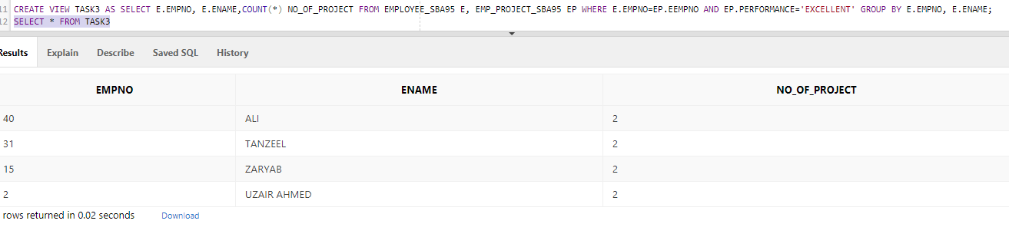

**Task 4**

Simple views have data only one table, while complex views have the option to store data from multiple tables.

Simple views do not have functions, on the other hand, complex views do.

Simple views cannot contain groups of data, while complex views can.

We can view through DML in simple view but in complex views, it is not always the case.